
2022学年人教PEP版小学英语三年级下册期末阶段质量预测卷
姓名： 班级：
题号 | 一 | 二 | 三 | 四 | 五 | 六 | 七 | 八 | 九 | 十 | 总分
得分

听力部分
一、听音，选择听到的内容（5分）
1．听音，选出你所听到的单词，每小题读两遍。
( ) 1). A．hand B．head C．map
( ) 2). A．ten B．pen C．red
( ) 3). A．six B．big C．pig
( ) 4). A．body B．dog C．box
( ) 5). A．duck B．run C．fun
二、听音，选择正确答案（5分）
2．听音，选出与所听内容相符的图片，每小题读两遍。
( ) 1). A． B．
( ) 2. A． B．
( ) 3). A． B．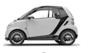
( ) 4). A．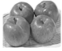 B．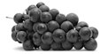
( ) 5). A． B．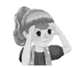
三、听音排序（5分）
3．听音，用1-5排序，每小题读两遍。
( ) Where is my map?
( ) How many balls do you have?
( ) Look at that giraffe. It’s so tall.
( ) Put your hand under your desk.
( ) We have two new friends today.
四、听音判断（5分）
4．听音，判断图片与录音内容是否相符。相符的打“√”，不相符的打“×”，每小题读两遍。
( ) 1). 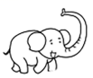( ) 2). ( ) 3). 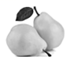
( ) 4). 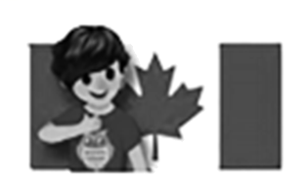( ) 5). 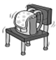

笔试部分
五、字母题（5分）
写出下列字母相对应的大写或小写字母。
5．B 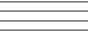
6．g
7．j
8．R
9．Y
六、词汇选择题（5分）
找出不同类的单词。
10．A．sister B．brother C．UK
11．A．giraffe B．desk C．chair
12．A．pear B．boy C．apple
13．A．short B．tall C．girl
14．A．fifteen B．twelve C．car
七、单选题（10分）
15．—______ are you from? ( )
—I’m from America.
A．Where B．Who C．How many
16．________ apple a day keeps the doctor away. ( )
A．a B．An C．A
17．My brother is not tall. He is ________. ( )
A．tall B．short C．thin
18．This is my dad. ________ is a teacher. ( )
A．He B．She C．It
19．—How many ________ do you have? ( )
—Nineteen.
A．dog B．kite C．kites
八、情景选择（10分）
20．当你想和别人打招呼，并介绍自己时，你应该说：( )
A．Hello, I’m Amy. B．Hi, she is Amy. C．Hello, she’s from the USA．
21．在动物园里，你想提醒朋友看远处那只熊，你应该说：( )
A．Look at that bear. B．Look at that panda. C．Look at that giraffe.
22．做了一件傻事后，你想表达一下自己懊恼的情绪，你应该说：( )
A．Bye! B．Silly me! C．Great!
23．当你想邀请别人一起去买梨子时，你应该说：( )
A．I like pears. B．Let’s buy some pears. C．Do you like pears?
24．你想称赞Sarah的书包很漂亮时，你应该说：( )
A．So beautiful! B．Me, too. C．It’s so big.
九、选词/短语填空（5分）
on short eleven grapes long
25．Look at this elephant. It has a ________ nose. 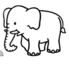
26．The books are ________ the desk. 
27．I don’t like bananas. I like ________. 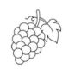
28．—How many pears do you see? —I see ________. 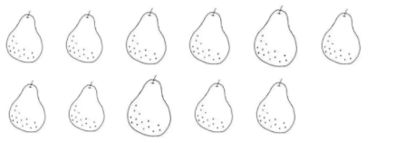
29．The dog has a ________ tail. 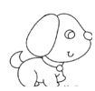
十、句子匹配（5分）
A．No, I don't.
B．I see 13.
C．She's my mother.
D．It's under the chair.
E. Sure. Here you are.
30．Who's that woman? ( )
31．Where is the ball? ( )
32．Do you like oranges? ( )
33．Can I have a pear, please? ( )
34．How many kites do you see? ( )
十一、选内容补全对话/短文（10分）
Amy: _____35_____
Chen Jie: He's my father.
Chen Jie: Hi, Dad. _____36_____
Dad: Nice to meet you!
Amy: _____37_____
Dad: Where are you from?
Amy: _____38_____
Dad: Welcome! _____39_____
Amy: Thanks.
A．Have some grapes.
B．Nice to meet you, too.
C．I'm from the UK.
D．Who's that man?
E．This is my friend, Amy.
十二、连词成句（10分）
40．back, to, welcome, school, (.)
______________________________________
41．in / It’s / desk / your (.)
___________________________________________
42．don’t I pears like (.)
_______________________
43．man / that / Who’s (?)
___________________________________________
44．so It's tall (.)
____________________________________
十三、阅读判断（10分）
Hi! I’m Tony. I’m tall and thin. Today is my birthday. I go to the zoo with my mother. There are many different animals there. I see eight giraffes, fourteen elephants, fifteen monkeys, nineteen pandas and twenty birds. They are very cute. And we buy two toy bears. I’m very happy today.
45．Tony is thin and tall. ( )
46．Tony go to the zoo with his father. ( )
47．There are 13 monkeys in the zoo. ( )
48．The animals are very cute. ( )
49．They buy two toy pandas. ( )
十四、阅读选择（10分）
My name is Tim. I'm a boy. I'm from Australia. I'm 6 years old. I'm a new student. My father is a tall man. He is a teacher. He teaches English in our school. My mother is a beautiful woman. She is thin. She has big eyes and long hair. She is from the UK. My brother is Tom. He is 10. He is short. He is a funny boy. I love my family.
50．Tim is a ______. ( )
A．student B．girl C．teacher
51．Tim is ______ years old. ( )
A．five B．six C．ten
52．Tim's father is ______. ( )
A．fat B．tall C．short
53．Tim's mother has ______. ( )
A．big eyes B．long hair C．big eyes and long hair
54．Who is Tom? ( )
A．He's Tim's father. B．He's Tim's brother. C．He's Tim’s friend.

参考答案：
1． C A C B B
【详解】
1). map 2). ten 3). pig 4). dog 5). run
2． B A A B B
【详解】
1). Hi, I’m Zhang Peng. I’m from China.
2). This is my grandfather.
3). Put on a cap.
4). —Can I have some grapes?
—Here you are.
5). Big, big, big! Make your eyes big.
3． 2 4 1 5 3
【详解】
1). Look at that giraffe. It’s so tall.
2). Where is my map?
3). We have two new friends today.
4). How many balls do you have?
5). Put your hand under your desk.
4． √ × √ × ×
【详解】
1). The elephant has a long nose.
2). This is my brother.
3). I like pears.
4). Mike is from the UK.
5). The bag is under the chair.
5．b
6．G
7．J
8．r
9．y
10．C
11．A
12．B
13．C
14．C
15．A
16．B
17．B
18．A
19．C
20．A
21．A
22．B
23．B
24．A
25．long
26．on
27．grapes
28．eleven
29．short
30．C
31．D
32．A
33．E
34．B
35．D
36．E
37．B
38．C
39．A
40．Welcome back to school.
41．It’s in your desk.
42．I don’t like pears.
43．Who’s that man?
44．It's so tall.
45．T
46．F
47．F
48．T
49．F
50．A
51．B
52．B
53．C
54． B

